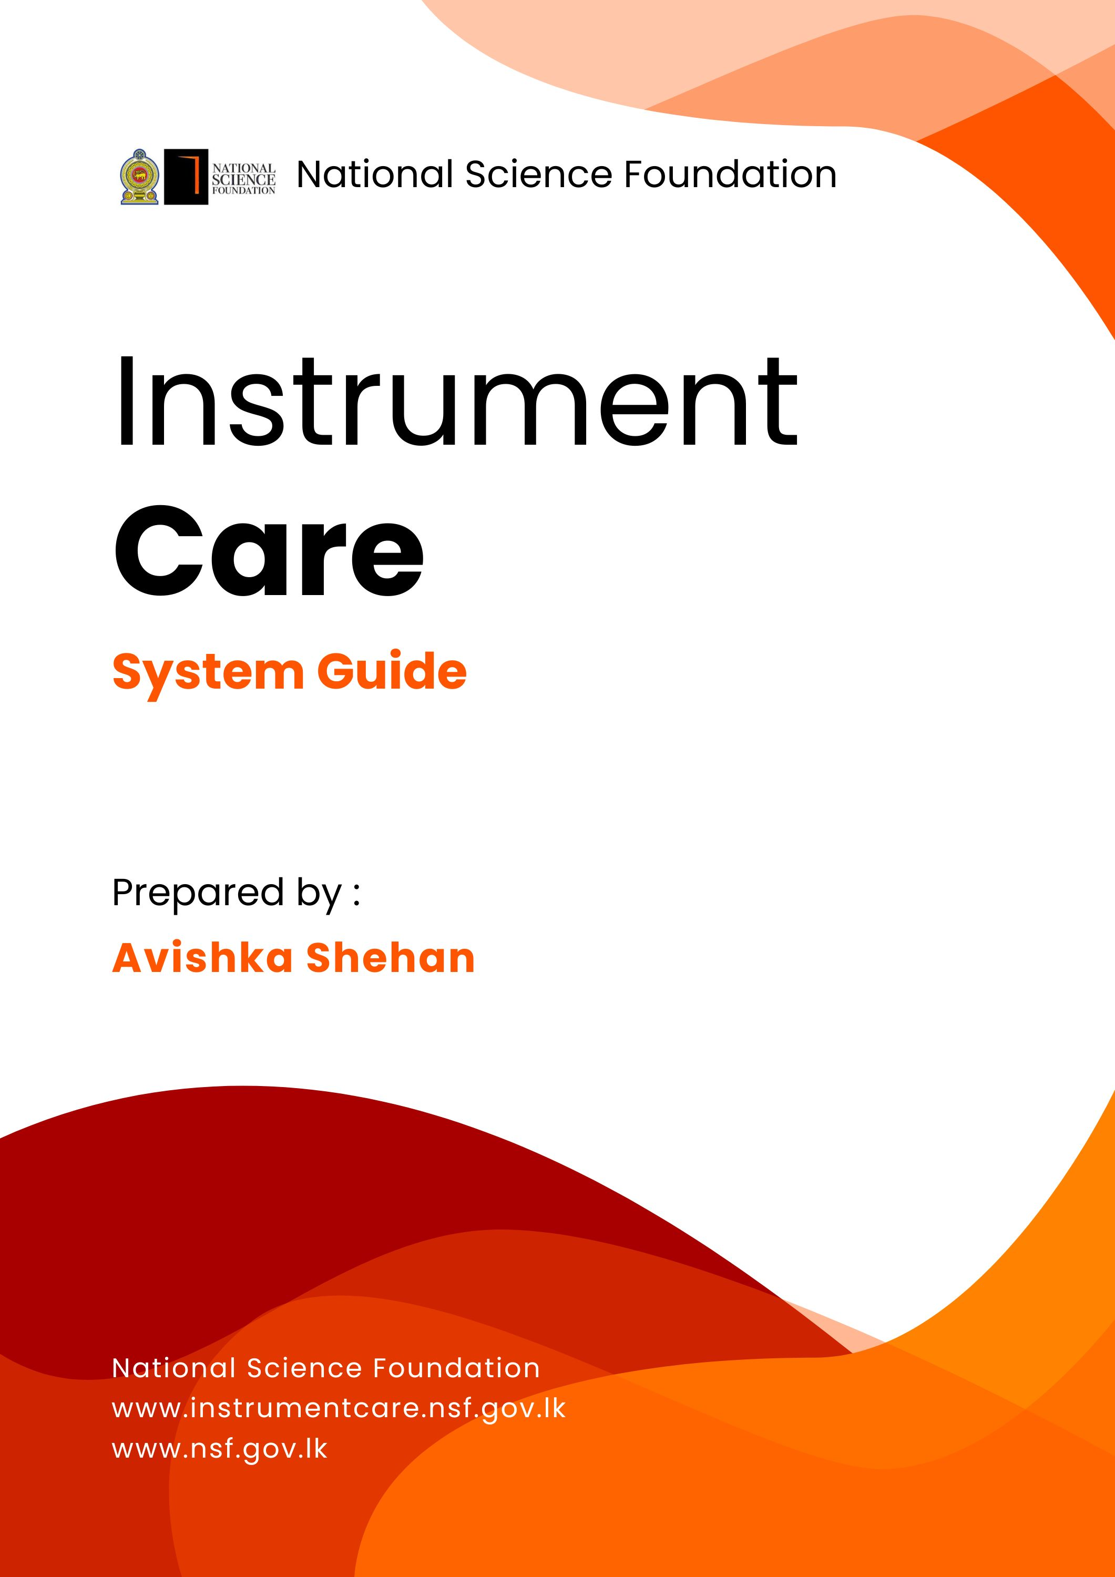


Home Page
Go to Technician
Registration Page
Go to Login Page
Go to Contact Page
Go to Technician Page
Go to About Page
Go to Home Page

Go to Login Page
Go to Technician Page
Redirected to login page
If you are already logged in then it redirected to the technician page inside the system. If you not log in then it shows login page.

Go to Technician Page
If you are already logged in then it redirected to the technician page inside the system. If you not log in then it shows login page.

Go to Technician Page
If you are already logged in then it redirected to the technician page inside the system. If you not log in then it shows login page.

About Page



Redirect to NID
National Instrument Database

Go to Previous message
Go to next message


Technician Page

Go to Technician Page

If you are already logged in then it redirected to the technician page inside the system. If you not log in then it shows login page.

Technician Card

Go to Service Request page

Go to View Profile page

Go to Technician Page

If you are already logged in then it redirected to the technician page inside the system. If you not log in then it shows login page.

Contact Page
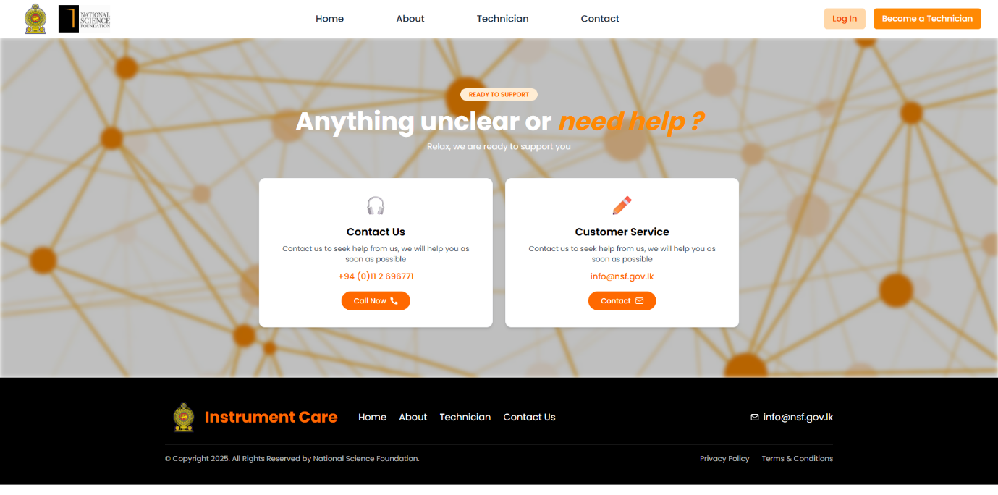

Login Page



Enter Username
Go to Technician Registration Page
Enter Password
Go to forget password process

Sign In Button
(Click here to sign in)

Technician Registration Page

